Power BI Licensing Comparison

This document provides an in-depth analysis of the types of Power BI licenses, their differences, and the benefits of Power BI Premium over Power BI Pro. It includes screenshots and relevant information from the official Power BI website.

# Types of Power BI Licensing

1. Power BI Free  
Description: This is the basic version of Power BI for individuals. It allows users to create and view reports and dashboards locally.  
Target Audience: Suitable for personal use or small projects.  
Features:  
- Access to Power BI Desktop.  
- Limited data capacity (1 GB per dataset).  
- No sharing or collaboration features.  
- No access to Power BI service for publishing reports or sharing with others.

2. Power BI Pro  
Description: Designed for individual users who need to create, share, and collaborate on reports and dashboards.  
Target Audience: Small to medium businesses or teams.  
Features:  
- All features of Power BI Free.  
- Ability to share and collaborate with other Pro users.  
- Integration with Office 365 and Azure AD.  
- 10 GB per user data storage limit.

3. Power BI Premium  
Description: Provides enterprise-grade capabilities with greater data capacity, performance, and scalability.  
Target Audience: Large enterprises.  
Features:  
- All features of Power BI Pro.  
- Dedicated cloud resources for faster performance.  
- Up to 100 TB of storage.  
- Ability to distribute content to free users within the organization.

4. Power BI Premium Per User (PPU)  
Description: Offers the benefits of Power BI Premium to individual users at a lower cost.  
Target Audience: Smaller organizations or users who require Premium features without needing full capacity.  
Features:  
- All features of Power BI Pro.  
- Access to advanced AI features and larger datasets. 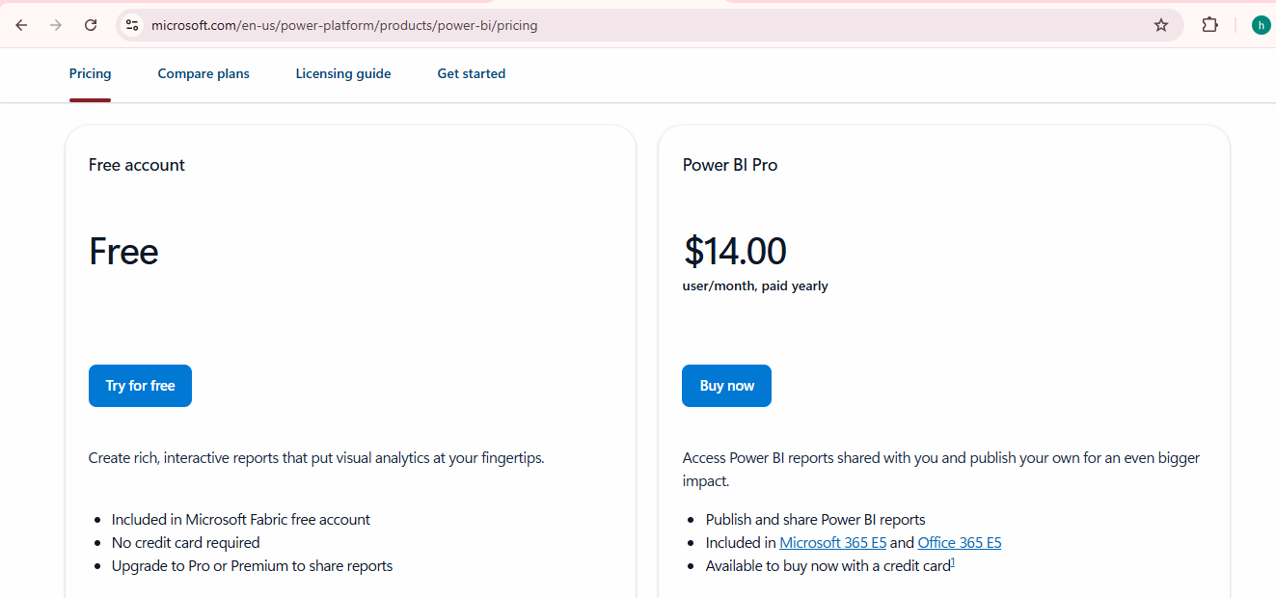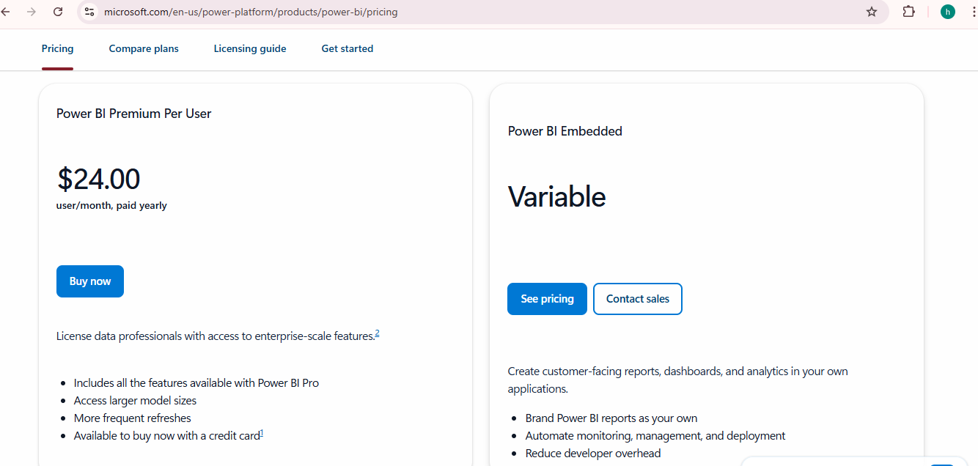

# Difference Between All Types of Licensing

|  |  |  |  |  |
| --- | --- | --- | --- | --- |
| Feature | Power BI Free | Power BI Pro | Power BI Premium | Power BI Premium Per User |
| Data Storage Limit | 1 GB per dataset | 10 GB per user | 100 TB | 100 TB |
| Sharing & Collaboration | No | Yes, with Pro users | Yes, with both Pro & free users | Yes, with both Pro & free users |
| Data Refresh | Daily refresh | Up to 8 times/day | Up to 48 times/day | Up to 48 times/day |
| AI & Advanced Analytics | No | No | Yes | Yes |
| Report Server | No | No | Yes | No |
| Maximum Dataset Size | 1 GB | 10 GB | Up to 400 GB | Up to 400 GB |

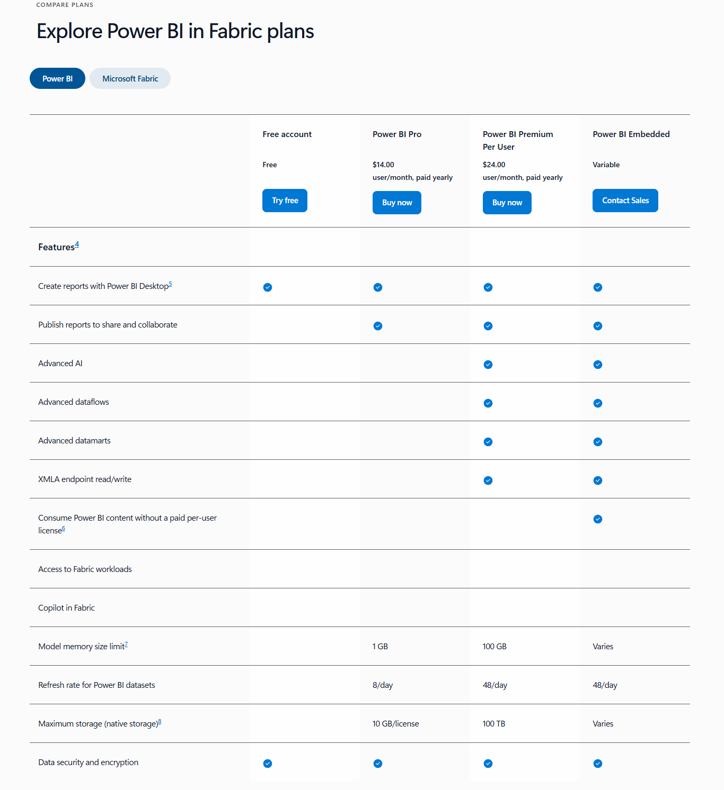

# Benefits of Power BI Premium Over Power BI Pro

1. Larger Datasets and Better Performance  
 Power BI Premium supports datasets up to 400 GB, significantly higher than the 1 GB limit in Power BI Pro. Premium users get faster report generation times due to dedicated cloud resources.  
  
2. More Storage  
 Premium offers up to 100 TB of storage compared to just 10 GB for Pro.  
  
3. Sharing with Free Users  
 Premium allows sharing content with users who do not have Power BI Pro licenses.  
  
4. Advanced AI and Analytics  
 Premium includes advanced AI-powered analytics, machine learning models, and dataflow transformations.  
  
5. Enhanced Data Refresh  
 Premium allows up to 48 data refreshes per day, while Pro supports only 8.  
  
6. Power BI Report Server  
 Premium includes Power BI Report Server, allowing on-premises report hosting.  
  
7. Dedicated Cloud Resources  
 Premium provides dedicated cloud resources, enhancing performance and scalability.  
  
8. Paginated Reports  
 Premium enables paginated reports for pixel-perfect, printable reports.  
  
9. Power BI for Embedded Analytics  
 Premium includes Power BI Embedded for integrating reports and dashboards into applications.